From Ireland to the Adirondacks
The Story of William Quirk and Ellen Howard
and of the family, the neighbors, and the sixty-four acres they made their own
Compiled from original records for the Quirk family reunion
July 2026

The Family Tree: Four Generations at a Glance
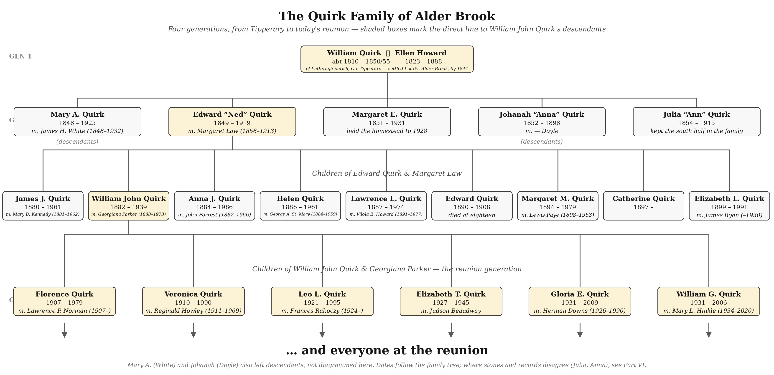
Four generations, drawn from the family’s verified tree. Shaded boxes trace the direct line shared by everyone at the reunion: William & Ellen, their son Edward and Margaret Law, their son William John and Georgiana Parker, and William John’s six children. Mary A. (White) and Johanah “Anna” (Doyle) also left descendants beyond this chart. Find the person you descend from here, then read on for the whole story.

Contents
The Family Tree: Four Generations at a Glance 2
Introduction: A Letter to the Family 4
Part I. Ireland: A Neighborhood in North Tipperary 5
Part II. The Crossings, 1840s 6
Part III. Alder Brook: A Townland Rebuilt in the Adirondacks 8
Part IV. The Lost Years: William’s Death, 1850–1855 10
Part V. The Widow’s Farm, 1855–1888 12
Part VI. The Five Children 13
Part VII. The Neighborhood, Mapped: The 1876 County Atlas 15
Part VIII. Family Lore 16
Part IX. The Land Itself, 1844 to Today 21
Part X. The Stones of St. Rose of Lima 23
Part XI. What We Are Still Looking For 25
Sources and Records Consulted 26
With Thanks 27

Introduction: A Letter to the Family
This document was made for you. If you are reading it, you are almost certainly a descendant of William Quirk and Ellen Howard, two young people from neighboring hillsides in County Tipperary, Ireland, who crossed an ocean in the 1840s, cleared sixty-four acres of Adirondack forest in the town of Franklin, New York, and started the family that fills the room at this reunion. The tree at the front of this document shows the line from the two of them down to the generation most of us knew personally: the children of William John Quirk and Georgiana Parker. Find your own parent, grandparent, or great-grandparent on it, and everything in the pages that follow is the story of where they, and you, come from.
It is quite a story. It includes a famine dodged by months, a widow who could not write her own name but built and held a farm for thirty-three years, a blind daughter provided for with remarkable care, a hamlet in the Adirondacks that was really a transplanted Irish townland, a will signed with an X in a farmhouse kitchen full of cousins, and a piece of land that stayed connected to this family and its old Tipperary neighbors for the better part of a century, and whose boundary lines are still visible on a modern map. None of it is invented. Every fact in this document comes from an original record: a deed, a census page, a ship arrival card, a probate file, a tombstone, an Irish land survey, an atlas from 1876. The most important of those records are reproduced as images throughout, so you can see them exactly as the family’s researchers found them. Where something is a working theory rather than an established fact, the text says so plainly.
The document is arranged as a story, in eleven parts: Ireland and the two families’ origins (Part I); the ocean crossings (Part II); the settlement at Alder Brook (Part III); the death of William, the mystery that started this whole project (Part IV); Ellen’s long widowhood and her farm (Part V); the lives of their five children (Part VI); the remarkable 1876 map that shows the entire community at home at once (Part VII); a collection of family lore, the stories the records were hiding (Part VIII); the journey of the land itself from 1844 to the present day, including the modern street addresses where the farm still lies (Part IX); the cemetery at Alder Brook where the first generations lie (Part X); and finally the open questions we are still chasing (Part XI), because this research is not finished, and someone at this reunion may hold the missing piece in an attic, a shoebox, or a memory.

How this project began
It began with a single stubborn gap. The family tree showed William Quirk, born about 1810 in Ireland, husband of Ellen, father of five, and then: death “before 1855, unconfirmed.” No death certificate exists, because New York did not require them in his lifetime. No tombstone bears his name, except as a phrase carved on his wife’s: “Ellen, Wife of William Quirk.” In trying to close that one gap, the search opened into everything else in these pages: deeds, censuses, farm schedules, probate testimony, ship manifests, cemetery transcriptions, Irish valuations, and maps, which together turned out to hold nearly the whole story of two interlocking families and the ground they shared on both sides of the Atlantic.
Read it in order, or skip straight to the pictures, or start with the part about your own branch. And if anything here sparks a memory, a correction, or an old story, that is not an interruption; it is the point. This is a living document, and the next edition of it may well begin with something said at this reunion.

Part I. Ireland: A Neighborhood in North Tipperary

The townlands
Every thread of this family leads back to a cluster of townlands in the civil parish of Latteragh, barony of Upper Ormond, County Tipperary, on the slopes between Nenagh and the Silvermine Mountains. The places that recur in our records sit within a ten-mile arc of one another: Latteragh itself, where Ellen Howard was born; Templederry, the Catholic parish that served these townlands and the place her brother Timothy’s American tombstone names as home; Toomevara, where her half-sister’s children were baptized and where her father died; and Silvermines and Nenagh, home of the Quirke relations. When different records seem to name different home places, they are all describing the same small neighborhood seen through different windows.

The Howards of Glenmore Upper
Ellen’s father, Laurence Howard (1795–1868), married Mary Margaret Kennedy (1799–1879) at Nenagh in February 1819. Their children included Ellen (born 1823 at Latteragh), Timothy (1824), Thomas (1826), Patrick (1830), Mary (about 1830), Dennis (1834), another Mary (1843), and Johanna (1845). Laurence also had a much older half-sister, Sarah “Sally” Howard (born about 1805), who married a Ryan and whose family would matter greatly to this story in America. Ancestry’s DNA tools mark Laurence and Mary Margaret as common DNA ancestors of living descendants, meaning the paper trail assembled here is corroborated by genetics.
Griffith’s Valuation, the great mid-century survey of Irish landholding, shows the family in place. In Glenmore Upper townland, Lawrence Howard held a house, office, and garden under Michael Dwyer, plus land under the Earl of Orkney; his son Patrick Howard held a house nearby; a Michael Howard, Ryans, and Kennedys filled out the same page. Laurence and Mary Margaret never emigrated. He died at Toomevara in 1868; most of their children, one by one, left for America.

The Quirkes of Baurroe and Curragh
The same valuation shows the Quirkes as tenant farmers two townlands away. In Baurroe, Michael, John, and Philip Quirke each held house and land under John Lanigan, Esq., with a Cornelius Kennedy holding land practically beside them. In Curragh, Jeremiah, John, and James Quirke held under the Earl of Orkney. The earlier manuscript field books for Baurroe add one more name of particular interest: a Mary Quirk, a woman heading a farm holding, which in that era almost always meant a widow. By the printed valuation of the early 1850s her holding had passed on.
Our working theory, not yet proven, is that this widow Mary was William’s mother, and that the Baurroe and Curragh Quirkes were his brothers, uncles, and cousins who stayed on the land while William and, eventually, his half-brothers scattered. William’s half-brothers are documented in the family tree: Patrick Quirke (1817–1867) of Silvermines and Edward Quirke (about 1833–1908), born near Nenagh, who emigrated to Australia. The presence of half-brothers means William’s father married twice, a pattern that appears on the Howard side as well.

What the naming of the children tells us
Irish Catholic families of this era named children by a strong convention: first son for the father’s father, first daughter for the father’s mother, second daughter for the mother’s mother, later children for aunts, uncles, and the parents themselves. William and Ellen’s children, in order, were Mary, Edward, Margaret, Johanna, and Julia. Mary points to William’s mother, which is exactly where the widow Mary Quirk of Baurroe fits. Edward points to William’s father, independently matching the family’s long-standing guess of “Edward” for that ancestor. Margaret matches Ellen’s mother, Mary Margaret Kennedy. Johanna matches Ellen’s youngest sister. Julia has no Howard counterpart, which quietly predicts a Julia on the Quirk side, a prediction the Templederry parish registers may yet confirm. A generation later, Edward’s own children repeat the pattern faithfully, honoring both grandfathers, his wife’s father James Law, his mother Ellen, and himself.

Part II. The Crossings, 1840s

William goes first
Family tradition holds that William came through Canada and was the first of his people to cross. The records are consistent with that. His later land deed contains a clause making the property “subject to taxes from October 9th, 1844,” strong evidence that the Quirk family was already living on that exact parcel by the fall of 1844. That places William in America years before the Great Famine, among the pre-famine emigrants who paved the way for everyone who followed. His precise arrival, whether the possible 1833 landing at Saint John, New Brunswick, the possible June 10, 1837 arrival at New York, or an unrecorded overland crossing from Canada, remains an open question. It is worth knowing that if he did come through Canada, no passenger list likely survives: Canadian arrival manifests before 1865 are almost entirely lost, and the land border into northern New York kept no records at all until 1895.

Ellen and Timothy, June 4, 1845
Ellen Howard, about twenty-two, and her brother Timothy, about twenty-one, sailed from Liverpool and landed at Boston on June 4, 1845, aboard a vessel recorded as the Sweden. They traveled as a pair, with no parents and no other Howards aboard, the classic pattern of chain migration in which an anchor already in America, very plausibly William himself, made the way for those who followed. The arrival index card reproduced below preserves the moment in a few spare lines: Howard, Ellen; accompanied by Timothy; age 22; nationality Ireland; destination U.S.; port of entry Boston, Mass.; June 4, 1845.
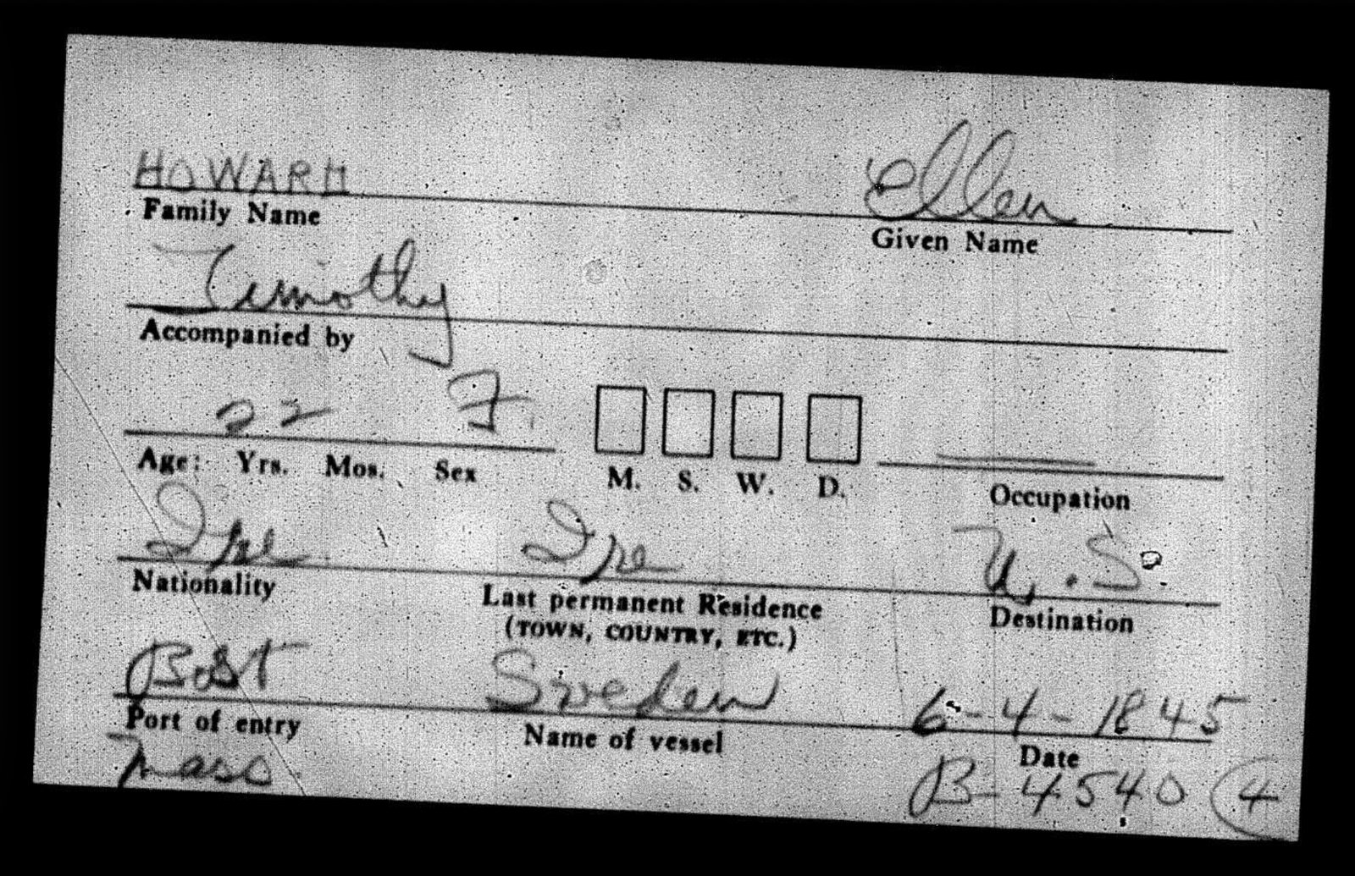
Boston arrival index card for Ellen Howard, accompanied by her brother Timothy: from Ireland aboard the Sweden, landing June 4, 1845. This is the moment the Howard side of the family arrives in America.
Their timing is worth pausing over: they left Ireland in the spring of 1845, months before the potato blight first struck that September. They left a poor Tipperary, not yet a starving one, and their siblings who crossed later would leave under far darker skies. Within roughly two years of stepping off the boat, Ellen married William, a neighbor’s son from the hillside next to her own. Their first child was born in New York in February 1848.

The rest of the chain
The family kept coming. Ellen’s brother Thomas Howard (born 1826) appears in the Quirk household by 1850, having crossed by some other ship. Her brother Dennis Howard (1834–1878) came and farmed nearby. Her half-aunt’s family, Sarah Howard Ryan with her husband and sons Thomas, Lawrence, and Dennis Ryan, transplanted as well. Her brother Patrick stayed in Ireland, holding his house in Glenmore Upper. Her youngest sister Johanna (1845–1918) also appears in the American record. On the Quirk side, William’s half-brothers took the other great road of the Irish diaspora, to Australia. One family’s dispersal, spanning three continents, all from a couple of hillsides above Nenagh.

Part III. Alder Brook: A Townland Rebuilt in the Adirondacks

Gerrit Smith’s land and Lot 65
The place they chose, or that chose them, was the Alder Brook country in the town of Franklin, Franklin County, New York, in the northern Adirondacks near the hamlet now called Sugarbush on State Route 3. Much of this wilderness belonged to Gerrit Smith of Peterboro, the wealthy reformer and abolitionist, who was famous for selling and granting his Adirondack lands to poor settlers on easy terms. The Quirks settled on the north quarter of Lot 65, Township 10 of the Old Military Tract: a long, narrow strip of sixty-four acres, about a quarter mile wide and well over a mile long, running from the road up and over an 1,800-foot hill. Road-front flats for tilling, mid-slopes for meadow and pasture, and hillside forest for firewood and maple sugar. They occupied it from about 1844, more than a decade before they owned it.

The 1850 census: a household portrait
On September 3, 1850, the federal census taker recorded dwelling 34, family 35, in the town of Franklin: William Quirk, forty, farmer, born Ireland; Ellen, twenty-eight, born Ireland; little Mary and infant Edward, both born New York; Sarah Ryan, forty-five, born Ireland; and Thomas Howard, twenty, born Ireland. It is the only census William ever appears in, and it is a portrait of the chain in motion: his wife’s young brother boarding while he got established, and his wife’s half-aunt Sarah under the same roof. The real estate column beside William’s name is blank, because the family occupied but did not yet own the land. Neither William nor Ellen could read or write, a mark that would echo decades later when Ellen signed her will with an X. The original page is reproduced below, and it repays a slow look: the surrounding households, Kellys, Collinses, Wallaces, Gleasons, Tierneys, and a young Cornelius Ryan, are the same families who will surround the Quirks in every record for the next eighty years.
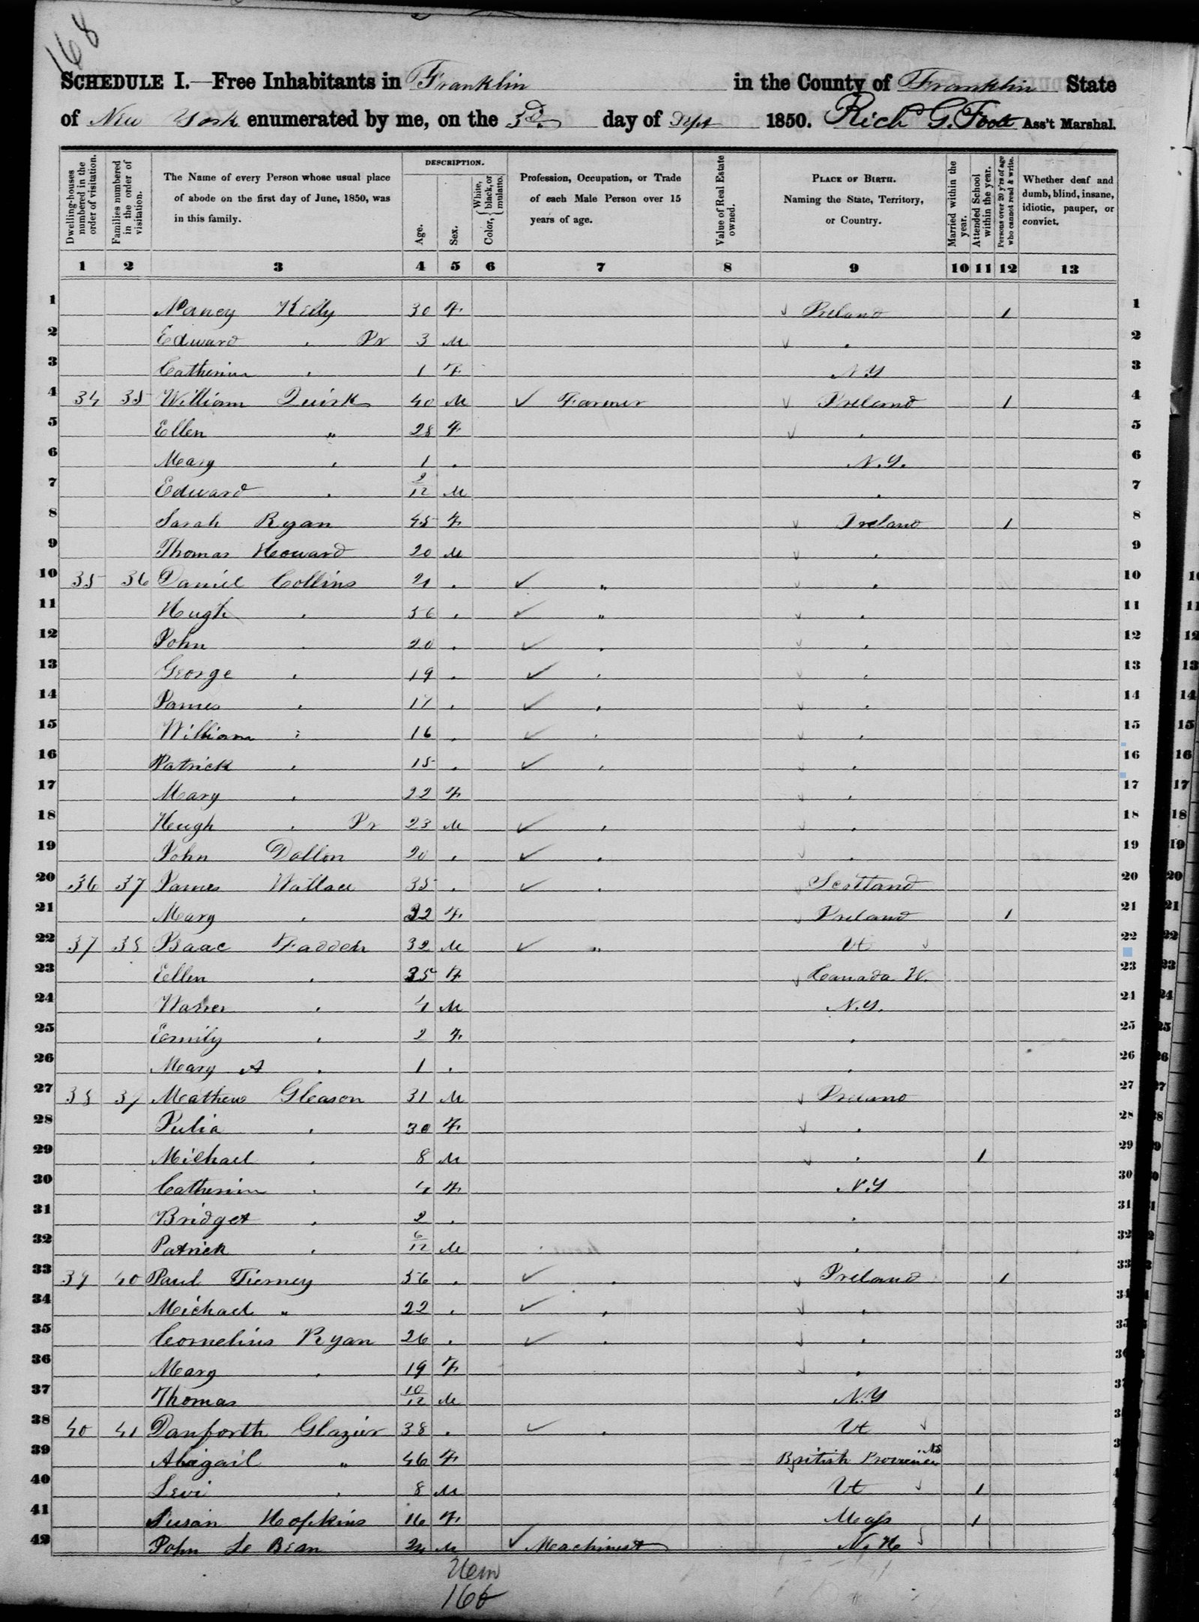
The 1850 federal census, town of Franklin, enumerated September 3, 1850. Lines 4 through 9 are the Quirk household: William, Ellen, Mary, Edward, Sarah Ryan, and Thomas Howard. This is the only record in which William Quirk appears alive.

The transplanted community
Walk the census pages, the 1880 farm schedules, and the stones of St. Rose of Lima Cemetery and the same surnames repeat: Howard, Ryan, Keese, Gleason, Tierney, Wallace, Collins, Kennedy, O’Neil, Dewey. The stones themselves name the origins: natives of Templederry, of Cappawhite, of Gurreeney, of Tipperary parish after Tipperary parish. Alder Brook was not settled by generic Irish immigrants. It was one rural neighborhood of north Tipperary, picked up and set down in the Adirondacks with its marriage networks, its feuds and friendships, presumably intact. The Irish influx to Alder Brook peaked in 1848 and 1849 as famine emigrants poured in; the Quirks, already established for several years by then, would have been among the receiving households.

Part IV. The Lost Years: William’s Death, 1850–1855
William Quirk appears alive and farming in September 1850. He never appears in a record again. Five years later, on July 30, 1855, Gerrit Smith and his wife Ann Carroll Smith deeded the sixty-four acres of Lot 65, for one hundred fifty dollars, to Ellen alone: “Ellen Quirk, of the Town and County of Franklin … in her actual possession now being … to her heirs and assigns forever.” No husband is named anywhere in the instrument. A married woman could legally buy land in her own name in New York by then, but a wife purchasing the family homestead solo, combined with William’s total disappearance from every subsequent record and the later documents that repeatedly call Ellen a widow, makes the conclusion all but certain: William died between September 1850 and July 1855, in his early forties, leaving five children under the age of eight. The recorded deed is reproduced below, the founding document of the family’s eight decades on the land, and the sharp-eyed will find the clause that started this whole research project: “Subject to taxes from October 9th, 1844,” the line proving the Quirks were living on Lot 65 a full eleven years before they owned it.
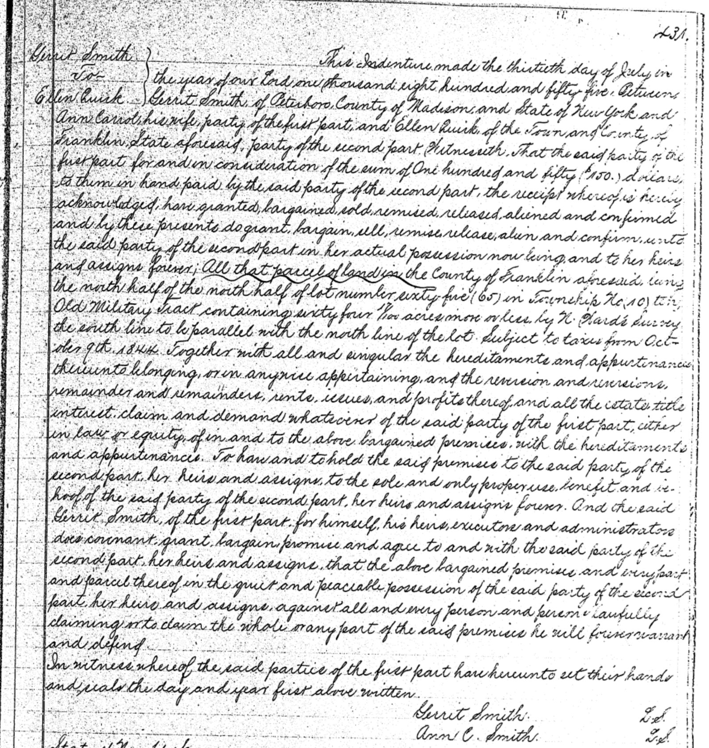
The deed of July 30, 1855: Gerrit Smith and Ann Carroll Smith to Ellen Quirk, the north quarter of Lot 65, sixty-four acres for $150. Recorded in Franklin County Deeds, Liber 24, page 431. Ellen alone is the grantee; William was gone.
There is a further hint in the children’s birth dates. The youngest, Julia, was born in 1854 by most family records (her tombstone says August 14, 1851, one of several small discrepancies noted at the end of this document). If the 1854 date is right, William was alive in 1853, and his death narrows to roughly 1853–1855, perhaps within months of his youngest daughter’s birth.
He has no gravestone at St. Rose of Lima, though burials there date back to the 1840s. Almost certainly he lies in that cemetery in an unmarked grave, as many of the community’s earliest dead do. When Ellen’s stone was carved in 1888, thirty-three years after his death, the family had his name etched into it: Ellen, Wife of William Quirk. It is, so far, his only monument. Finding his actual death date remains the top research priority, and the avenues still open are listed in Part XI.

Part V. The Widow’s Farm, 1855–1888

Ellen, farmer
What Ellen did next is the spine of this whole story. A widow in her early thirties who could not read or write, with five children under ten, she bought the farm, ran it, and never let it go. The 1860 census lists her, memorably, not as “keeps house” but as farmer, with real estate worth four hundred dollars, the sixty-four acres she had bought for one hundred fifty already valued at nearly triple her purchase price, and all five children at home. In 1870 the farm’s value had risen again, five hundred dollars in land and two hundred thirty-five in personal property. In 1880 she was fifty-six, still head of the household, with the federal agricultural schedule recording her as owner of a working hill farm: roughly thirty tilled acres, twenty-five to thirty in meadow and pasture, nineteen in woodland, fifteen tons of hay mown, ninety dollars of livestock. The neighboring lines on that schedule read like the parish register of old Latteragh: Elisabeth Howard (her brother Dennis’s widow), Patrick Ryan, Mathew Gleason, her son Edward Quirk, her brother Thomas Howard, Cornelius Ryan, John Ryan, Darby O’Neil. Every one an owner.

Margaret
The censuses of 1870 and 1880 both record Ellen’s daughter Margaret as blind, from at least her teens. This fact quietly explains almost every decision Ellen made in her last years. Margaret lived at home her whole life, and her security became her mother’s central project.

A brief second marriage
Ellen appears as Quirk in the censuses of 1860, 1870, and 1880. But her 1886 will names her Ellen Coughlin, widow, and her 1888 probate proceeds under that name, even though her tombstone restores her to Quirk. Between June 1880 and November 1886, in her early sixties, Ellen married a man named Coughlin and was widowed by him within those same six years. We know nothing else about him. He left no census entry, no deed, no gravestone at St. Rose, no children. Because New York began statewide civil marriage registration in 1881, the marriage should be findable in the state index, and that search is active. One suggestive possibility, no more than that: Griffith’s Valuation shows a substantial Coghlan family, millers, in Garrane townland of Latteragh parish, the same parish the Howards came from. Her second husband may well have been one more emigrant from home, marrying a neighbor’s widow late in life.

The will: “fixed for her two girls”
On November 6, 1886, Ellen sent for Thomas Russell, the local justice of the peace, to draw her will. The witnesses gathered in her house were her own community in miniature: James Keese, of the Tipperary Keeses, signing by mark; Lawrence Ryan, her half-cousin, Sarah’s son, signing by mark; Russell himself; and Laurence Howard, her kinsman, whom she named sole executor. Russell later testified that she told him “she felt anxious about her two girls,” and that after signing she said “she was very glad to be through with it before the Almighty called her away, as she wanted this property fixed for her two girls.”
The will did exactly that. To Margaret, the north twenty-two acres of Lot 65, adjoining ten acres Margaret already owned. To Julia, the remaining roughly thirty-two acres on the south side, “and if this lot should run over sixty-four acres I want it to be divided equally on both my daughters Margaret & Julia Quirk.” Household goods, beds and bedding, cattle, sheep, hogs, horse, harness, ploughs, harrows, hens, geese, and wagon: half to each daughter. If the buildings fell entirely on one daughter’s share, she was to pay the other fifty dollars “to help to build house.” And to her other three children, Edward, Mary White, and Ann Doyle, one dollar each, the standard legal device to acknowledge an heir and prevent a contest, and in this family’s case a simple recognition that those three were married, established, or, in Edward’s case, prospering, while Margaret and Julia had no other future than the land.

Death and probate
Ellen died March 20, 1888, aged about sixty-seven. Her brother Timothy, the sibling who had shared the crossing from Liverpool forty-three years before, had died seven weeks earlier, on February 1. They are buried in the same cemetery. Laurence Howard filed her will for probate on November 7, 1888; citations were served on Edward, Margaret, and Julia at Franklin on December 3, and on Mary White and Ann Doyle on November 12; and on December 31, 1888, Surrogate Horace A. Taylor heard the witnesses, admitted the will to probate, and issued letters to the executor. No one contested anything. The estate paperwork sat quietly until 1907, when the probate was finally recorded in the county deed books to perfect the daughters’ record title, which is why some family notes show a 1907 transfer; the land actually passed at Ellen’s death in 1888 under the will.

Part VI. The Five Children
The four-generation family tree diagram at the front of this document shows how these five, and the reunion generation, connect.

Mary A. Quirk White (February 1848–1925)
The firstborn, named by convention for William’s mother. She married James H. White (1848–1932), a Civil War veteran of Company A, 61st New York Volunteers. They raised a family and buried too many children young, as the White monument at St. Rose of Lima records. Mary lived to be seventy-seven.

Edward “Ned” Quirk (1849/50–1919)
The only son, named for William’s father. In 1880, at thirty, he was newly married to Margaret Law (1856–1913, daughter of James Law of County Antrim) and farming a ten-acre corner beside his mother, with fifty dollars’ worth of farm to his name. Ten years later, on May 28, 1890, he paid thirteen hundred dollars for the north half of Lot 66, the next lot in the grid, one hundred sixteen acres bought from John, Bridget, and Catherine Ryan, with three-quarters of an acre reserved for the district schoolhouse where his own children learned to read, the first generation of this family that could. Edward and Margaret raised a large family, including James J. (1880–1961, who married Mary Bridget Kennedy, returning that old allied surname to the line), William John (1882–1939, named for his grandfather), and children honoring nearly every ancestor in this document. Edward died June 2, 1919, one of the substantial farmers of the road his father had cleared.

Margaret Quirk (1851–1931)
Blind from at least her teens, Margaret never married and never left the homestead. Under her mother’s will she held the north half of the farm, and she held it for forty years, selling only in 1928, three years before her death at about eighty. From William’s settlement in 1844 to Margaret’s sale in 1928, the family’s tenure on Lot 65 ran eighty-four years.

Johanna “Anna” Quirk Doyle (1852–about 1898)
Named for Ellen’s youngest sister, she married a Doyle. Her stone at St. Rose of Lima reads “Anna, Dau of W. & E. Quirk, died April 20, 1898, age 44 yrs,” one of only two stones in the cemetery that name William directly. Some family records show an 1892 death; the tombstone date is likely the better evidence, and reconciling the two is on the open-questions list.

Julia Quirk (1854 or 1851–1915)
The youngest, whose name hints at an undiscovered Julia on the Quirk side in Ireland. She inherited the south half of the homestead, never married, and near the end of her life deeded her land to her cousin Dennis Howard’s line, keeping it in the wider family. Her stone gives a birth date of August 14, 1851, while family records say 1854; the cemetery’s transcribers noted that this graveyard contains numerous stonecutter errors, and the 1860 census ages support the later date.

Part VII. The Neighborhood, Mapped: The 1876 County Atlas
One document shows everyone at home at the same moment. In 1876, a county atlas of Franklin County was published from surveys in which mapmakers walked the roads and wrote the name of each occupant beside each farm. The resulting plat of the Alder Brook and Merrillsville country, reproduced below, is the only record in this collection that places the entire community on the land simultaneously, every household in its lot, eight years before Ellen wrote her will. It was found by the family in 2026, and it connects nearly every dot in this story.
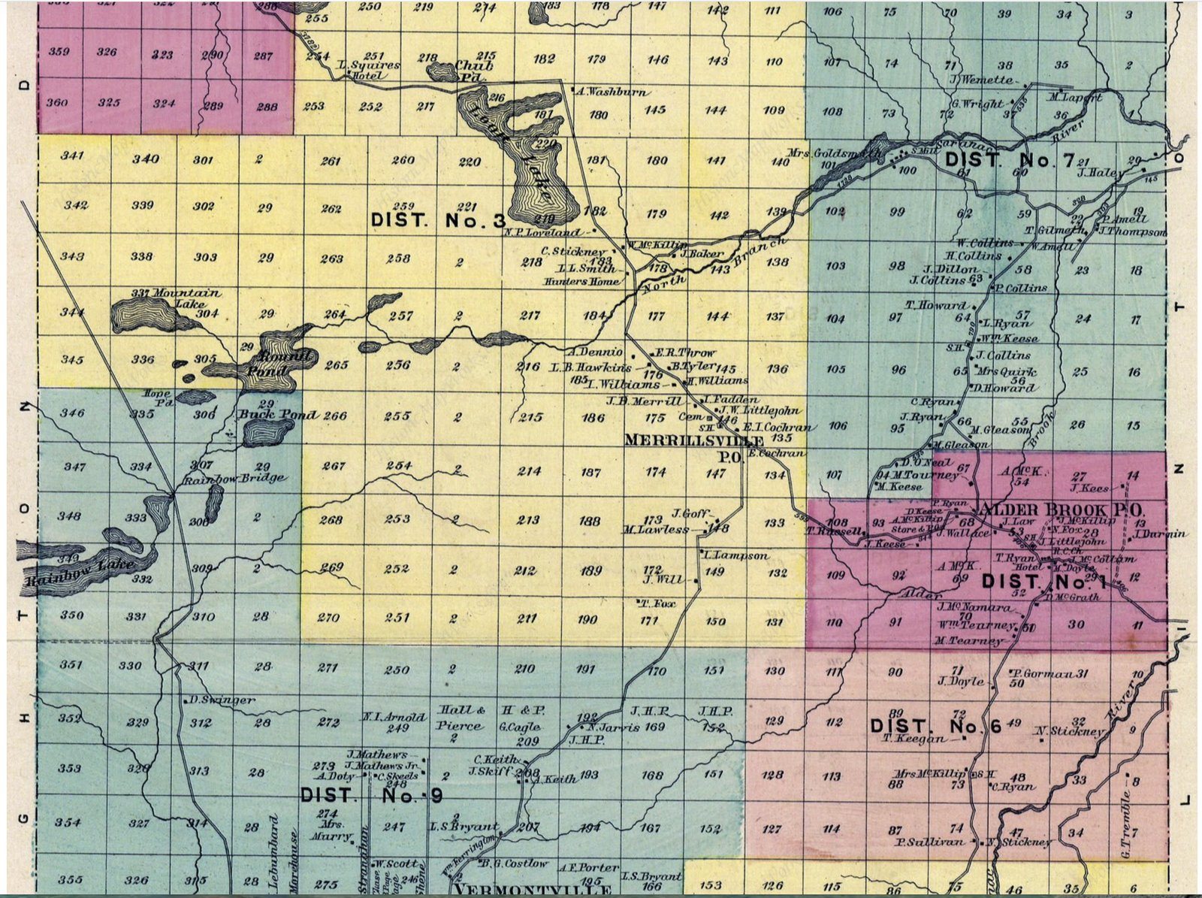
The Alder Brook and Merrillsville neighborhoods, town of Franklin, from the 1876 county atlas. “Mrs Quirk” appears at center right on Lot 65, surrounded by Howards, Ryans, Keeses, Gleasons, and the other families of this story.

“Mrs Quirk”
There she is, at the center right of the sheet: Mrs Quirk, on Lot 65 of the Old Military Tract, precisely where Gerrit Smith’s 1855 deed placed her. The atlas men recorded her the way the community knew her, not as anyone’s relict but simply as the head of her farm, one of only a handful of women named as landholders anywhere on the sheet (Mrs. Goldsmith, Mrs. McKillip, and Mrs. Marry are the others). Twenty-one years a widow by then, she had earned the printing of her name.

Reading the neighbors
What makes the map extraordinary for this family is the roll call surrounding her, because it shows that the relationships documented in the deeds, censuses, will, and cemetery were also simple physical adjacency. Her brother T. Howard farms Lot 64, immediately adjoining; the 1880 agricultural schedule will find him in the same place. Her brother D. Howard, Dennis, appears just below her, two years before his early death. On Lot 57, one lot over, stand L. Ryan and Wm. Keese: Lawrence Ryan, her half-cousin, and the Keese family, the very men who, ten years after this map was drawn, would stand in her kitchen and make their marks as witnesses to her will. On Lot 66, the next lot in the grid, are C. Ryan and J. Ryan, the Ryan family from whom her son Edward would buy that same north half of Lot 66 in 1890; the map is the “before” picture of that deed. M. Gleason, her fellow farm owner on the 1880 schedule, holds Lot 55. T. Russell, the justice of the peace who would draw her will, appears to the west. At the Alder Brook settlement itself are J. Law, whose daughter Margaret would marry Edward within a few years; the Doyle households into which her daughter Anna would marry; and the O’Neals, Tourneys, Collinses, Tearneys, and McCollums whose stones fill St. Rose of Lima beside the family’s own.

The institutions of a hamlet
The map also draws the infrastructure of their world. At Alder Brook P.O. cluster T. Ryan’s hotel, A. McKillip’s store and post office, a schoolhouse marked “S.H.,” and “R.C.Ch.,” the Roman Catholic church, the mission chapel of what became St. Rose of Lima parish. A second schoolhouse symbol stands near the Quirk lots, the district school the children attended; its sibling on Lot 66 is the very “three roods square of land for school house” reserved in Edward’s 1890 deed. The large numbered zones, District No. 1, No. 3, No. 6, No. 7, No. 9, are school districts. Merrillsville, with its own post office, cemetery, and school, anchors the western end of the neighborhood.
Seen whole, the sheet is the thesis of this document drawn in ink: a couple of hillsides’ worth of north Tipperary families, from Latteragh, Glenmore, Templederry, and Cappawhite, holding a couple of hillsides’ worth of adjoining Adirondack lots, with their church, their schools, their store, and one another. The townland was rebuilt, and in 1876 a mapmaker walked through it and wrote everybody down.

Part VIII. Family Lore
Everything in this section comes from real records: deeds, newspapers, muster rolls, and stones. Some of it is documented fact, some of it is charged but never proven, and all of it is ours.

The Abolitionist’s Land
Why was a landless Irish laborer able to settle sixty-four Adirondack acres in the first place? Because the ground belonged to Gerrit Smith of Peterboro, one of the richest men in New York and one of the great radicals of his age. Smith was a founder of the anti-slavery Liberty Party, famous for granting his Adirondack lands to Black New Yorkers and selling to poor settlers on terms no speculator would offer, and later one of the “Secret Six” who funded John Brown’s raid on Harpers Ferry. William settled on Smith’s Lot 65 around 1844 and owed back taxes, not rent. In 1855, Smith sold the entire farm to an illiterate Irish widow for one hundred fifty dollars. It was exactly the kind of transaction he was famous for, and it is the reason this family’s American story begins where it does. Our land came to us through one of the most remarkable men in American history, and most of us never knew it.
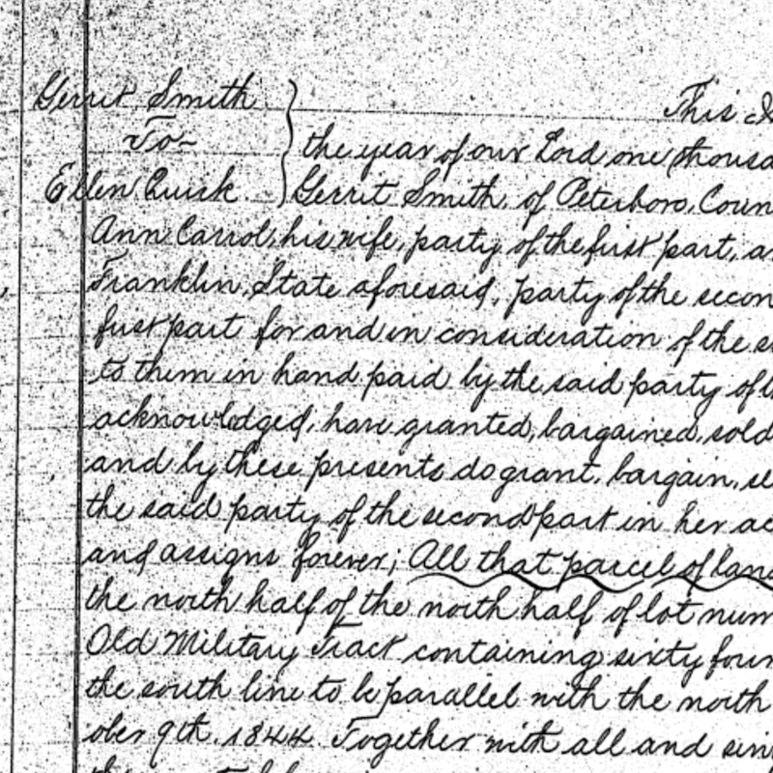
The opening of the 1855 deed: Gerrit Smith to Ellen Quirk.

They Married the Neighbors, For a Hundred Years
William Quirk and Ellen Howard grew up about two miles apart in Tipperary and married an ocean away in the Adirondacks. Then the pattern never stopped. Their grandson Lawrence married Vilola Howard in the 1910s. Their granddaughter Elizabeth married a Ryan in the 1920s. Their grandson James married a Kennedy, the same surname that farmed beside the Quirkes in the old townland and gave Ellen her mother. For three generations on a new continent, the family kept re-weaving the same handful of surnames from a couple of Irish hillsides, as if the Atlantic had never happened.
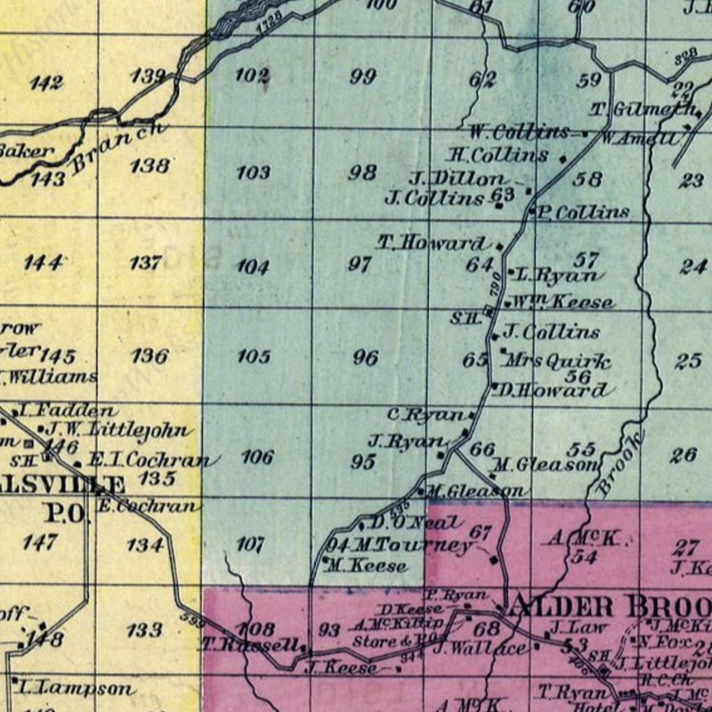
The neighborhood on the 1876 atlas: Quirk, Howard, Ryan, Keese, and Gleason lots side by side.

From X to Signature
William and Ellen signed every document of their lives with an X. Their son Edward kept the official books of School District No. 7 as its elected clerk. In 1890 Edward bought a farm with the district schoolhouse standing on it, three-quarters of an acre reserved in the deed, and his own children learned to write in that building on his land. The deed itself contains the whole transition on a single page: two of the older Irish-born sellers signed with X’s while a younger one signed her name. From illiterate to keeper of the records in exactly one generation. Ellen would have understood precisely what that meant.
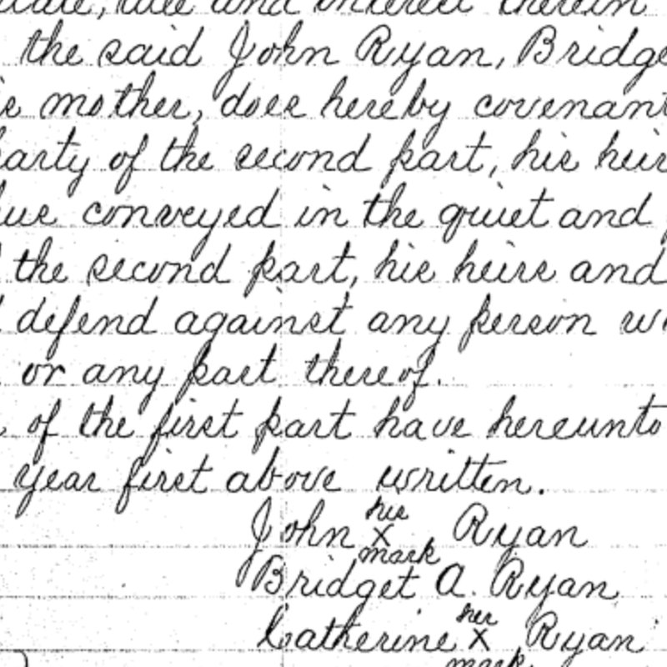
Signatures on the 1890 deed: two X marks and one signed name on the same page.

The Public Servants
The family that occupied its land for eleven years before owning it ended up running the public works. Edward served as Overseer of Highways for the Town of Franklin in the 1880s and 1890s, his name in the annual town audits beside the Howards and Ryans he’d grown up with. By 1905 he was clerk of the school district. A generation later his son William John was elected Superintendent of Highways for the Town of Brighton, renominated in 1935, his name printed in the Malone papers. Roads, schools, and record books: the quiet institutions of a settled people, kept by the descendants of two settlers who arrived with nothing.
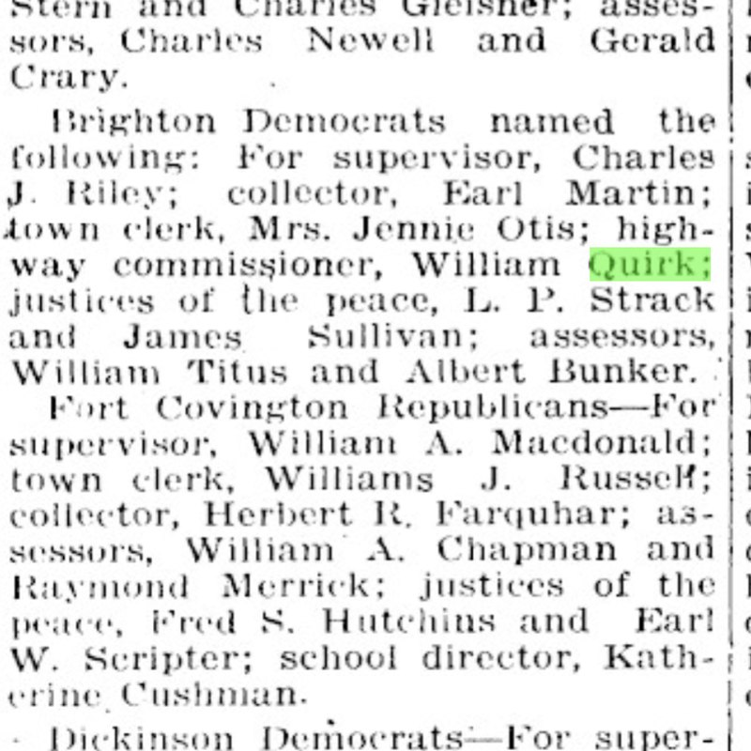
The Malone Farmer, October 1935: William Quirk nominated for highway commissioner of Brighton.

The Fire Observer’s Other Job
In May 1913 the papers announced that James Quirk of Sugar Bush had been appointed fire observer at Loon Lake Mountain, one of the early watchmen of New York’s brand-new fire tower system, scanning the forests his grandfather had helped clear. Thirteen years later his name appeared in the papers again, in the October 1926 Prohibition roundups: “Charged as ‘Bootleggers:’ … James Quirk, Sugarbush, Franklin County.” Franklin County sits twenty miles from Canada, and in the 1920s half the North Country had a hand in the whiskey trade. A charge is not a conviction, and no record of one has surfaced. But a man who knew every logging road and lookout in the county did possess, it must be said, certain professional advantages.
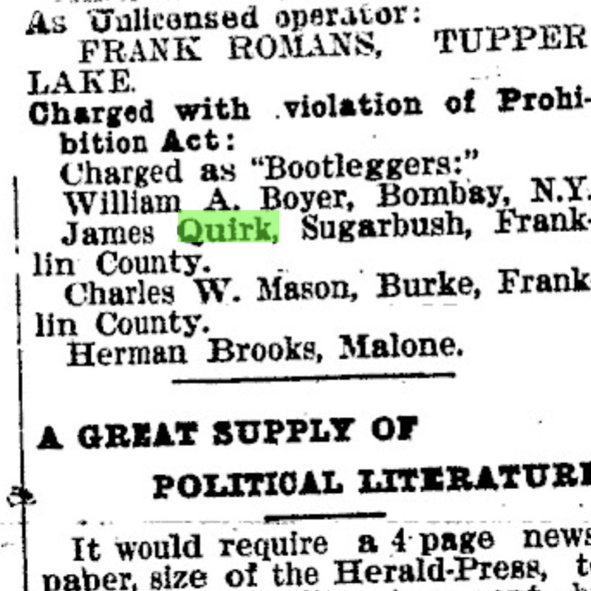
The Tupper Lake Herald, October 1926: the Prohibition roundup naming James Quirk of Sugarbush.

In Uniform
The family has worn the uniform in every generation since the Great War. Lawrence Leo Quirk registered for the WWI draft from a lumber camp in Washington State and served in France as a private in the 22nd Engineers, building military railways. He sailed home from Brest in July 1919 with his emergency contact still listed as his father Edward, who had died five weeks before the ship landed. His cousin Timothy White, Ellen’s grandson and namesake of the brother who shared her crossing, was a World War veteran dead at thirty that same year. In the next war, Staff Sergeant Leo Lawrence Quirk turned wrenches on Marine Corps aircraft at Quantico, and earned the family archive’s funniest document: a court-martial record for going AWOL at 8:15 one April evening in 1945 and surrendering himself at four o’clock the next morning, an absence of under eight hours. William Glenn Quirk enlisted in the Army at seventeen in 1949 and served through the Korea era. Terry Quirk carried the line into the modern Army with the 82nd Airborne. From a stateless arrival to five generations of service.
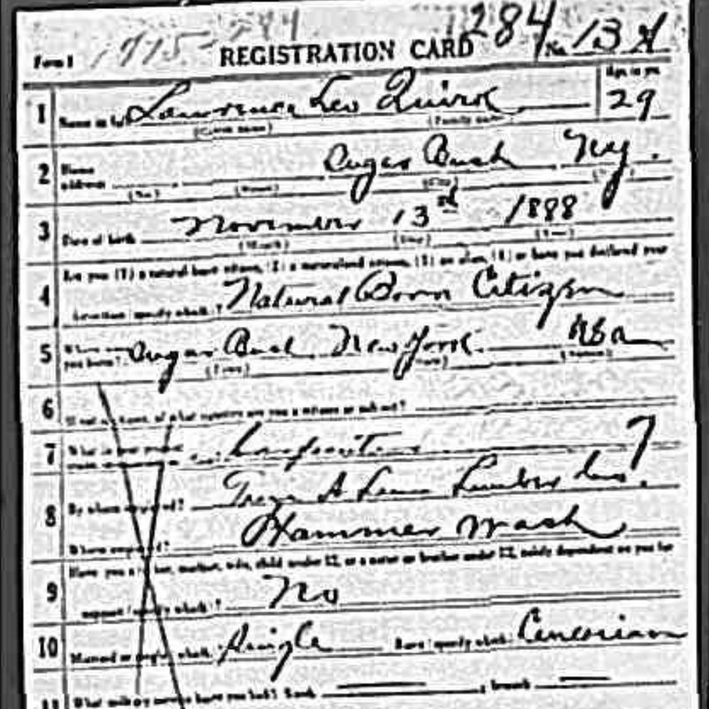
Lawrence Leo Quirk’s 1917 draft registration, filed from a Washington State lumber camp.

Names That Travel Through Time
The family named its children by the old Irish system, and the names carry messages if you know how to read them. William and Ellen’s first daughter Mary and first son Edward point straight back at William’s parents in Tipperary, and the records there confirm it: an Edward for a father, and a widow named Mary Quirk holding the old family farm. Lawrence Leo’s nephew was christened Leo Lawrence, the name flipped and sent back out. Three Williams carried three different middle names, and the “John” long attached to the immigrant William was probably his grandson’s name drifting backward through family memory. And the system makes one prediction the records haven’t answered yet: daughter Julia’s name says there was a Julia Quirke on a Tipperary hillside, still waiting to be found.

Footnotes & Coincidences
Ellen’s probate sat unrecorded in the county books for nineteen years; her son Edward recorded his deed in three days. The hill on the old farm is named Whooley Hill, for the family that bought the south half in 1938, while the man who first cleared it lies in an unmarked grave. H. Clark surveyed the property lines in 1855, and they are still visible from the air today, unchanged. And the words a county clerk wrote into Liber 24 that summer, “lot number sixty-five,” became the family’s address on the internet a hundred and seventy-one years later: lot65.org.

Part IX. The Land Itself, 1844 to Today
The sixty-four acres can still be stood upon. The original strip corresponds to real, present-day street addresses along State Route 3 at the hamlet of Sugarbush: the modern properties at 9979, 9986, and 10000 State Route 3, running west from the highway up and over Whooley Hill. These are today’s addresses, the kind you can type into a GPS; anyone driving Route 3 between Vermontville and Bloomingdale passes through the middle of William and Ellen’s farm. The family’s title research has traced every conveyance of the parcel from Gerrit Smith’s deed to the present owners, and the map below shows the original 1855 boundaries laid over the modern landscape, with the documented chain of ownership beneath it. (The current properties are private homes, so admire from the road, but the land itself is right there.)
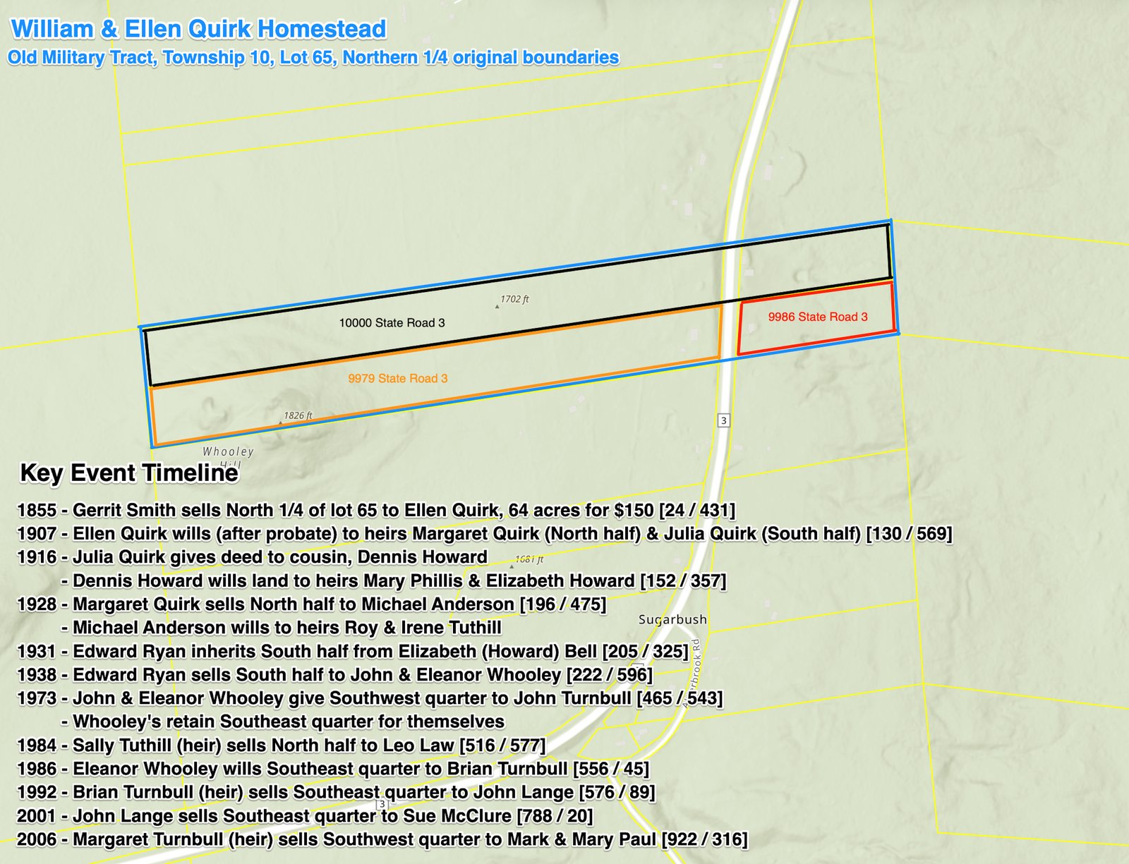
The original boundaries of the Quirk homestead (north quarter of Lot 65, Township 10, Old Military Tract) overlaid on the modern map, with the documented chain of title. The bracketed numbers, such as [24 / 431], are Franklin County deed book and page references: Liber 24, page 431 is the original 1855 deed from Gerrit Smith to Ellen Quirk. Anyone can request these instruments from the Franklin County Clerk in Malone by book and page.

How to read the timeline
Each entry on the map’s timeline is a real instrument sitting in the deed books at the county clerk’s office in Malone, and the bracketed [book / page] citations are the coordinates for finding them. One clarification to the 1907 entry, established during this research: title did not pass in 1907. The land passed to Margaret and Julia at Ellen’s death in March 1888, under the will admitted to probate that December. What happened in 1907 is that the probate was finally recorded in the county deed books [130 / 569] to perfect the daughters’ record title, a common practice when aging owners began thinking about disposition. Wills moved land automatically; paperwork caught up later.

What the chain of title says
Read as a story, the timeline is the family’s history told in dirt. It opens in 1855 with a widow paying one hundred fifty dollars for the ground her late husband had cleared, and it does not leave the family’s hands for the better part of a century. At Ellen’s death the farm divides exactly as she designed it, the north half to blind Margaret, the south half to Julia. Julia, near the end of her life, deeds her half not to a stranger but to her cousin Dennis Howard’s line, and when that line ends with Elizabeth (Howard) Bell in 1931, the south half passes to Edward Ryan, a descendant of the very Ryan families who sailed with, boarded with, and witnessed for the first generation. Not until 1938, ninety-four years after William first broke ground, does the south half leave the old Tipperary network entirely, sold to John and Eleanor Whooley, whose name the hill on the parcel now bears. Margaret, the last Quirk on the land, holds the north half until 1928, three years before her death, an eighty-four-year family tenure. From there the parcels move through the Anderson, Tuthill, Law, Turnbull, Lange, McClure, and Paul ownerships of the twentieth and twenty-first centuries, subdividing into the modern Route 3 properties on the map. The boundaries themselves never changed: today’s yellow parcel lines still follow H. Clark’s survey lines from the 1855 deed. The neighborhood turned over; the shape William and Ellen’s farm cut into the forest is still visible from the air.

Part X. The Stones of St. Rose of Lima
Everything else in this document is paper. This part is stone. On Alder Brook Road, a short drive from the homestead, stands St. Rose of Lima Roman Catholic Cemetery, known locally in earlier generations as Father O’Donnell’s Cemetery, and it is where this story’s people lie. For a family whose first generation left no photographs, no letters, and barely a signature, the cemetery is the most concrete evidence there is: names and dates and origins cut into marble by people who knew them, standing in the open air where any descendant can walk up and read them. Much of this document was built by checking every paper record against these stones, and the stones held up.
At the center of it all is Ellen’s marker, photographed below: a white marble tablet crowned with a cross and the IHS monogram. The inscription reads: “ELLEN, Wife of WILLIAM QUIRK, Died Mar. 20, 1888, Æ. 67 Yrs. May she rest in Peace.” Read it slowly, because it is doing more than marking a grave. Ellen had legally been Ellen Coughlin for years when she died; her will and probate carry that name. But the children who ordered this stone restored her, permanently, to the identity that mattered: wife of William Quirk, the husband she had buried thirty-three years earlier. And because William himself lies somewhere in this same ground without a marker of his own, these five carved words, “Wife of William Quirk,” are, to this day, his only monument. The stonecutter’s Æ. is the Latin aetatis, “aged”: sixty-seven years, matching her birth about 1821 in Latteragh.
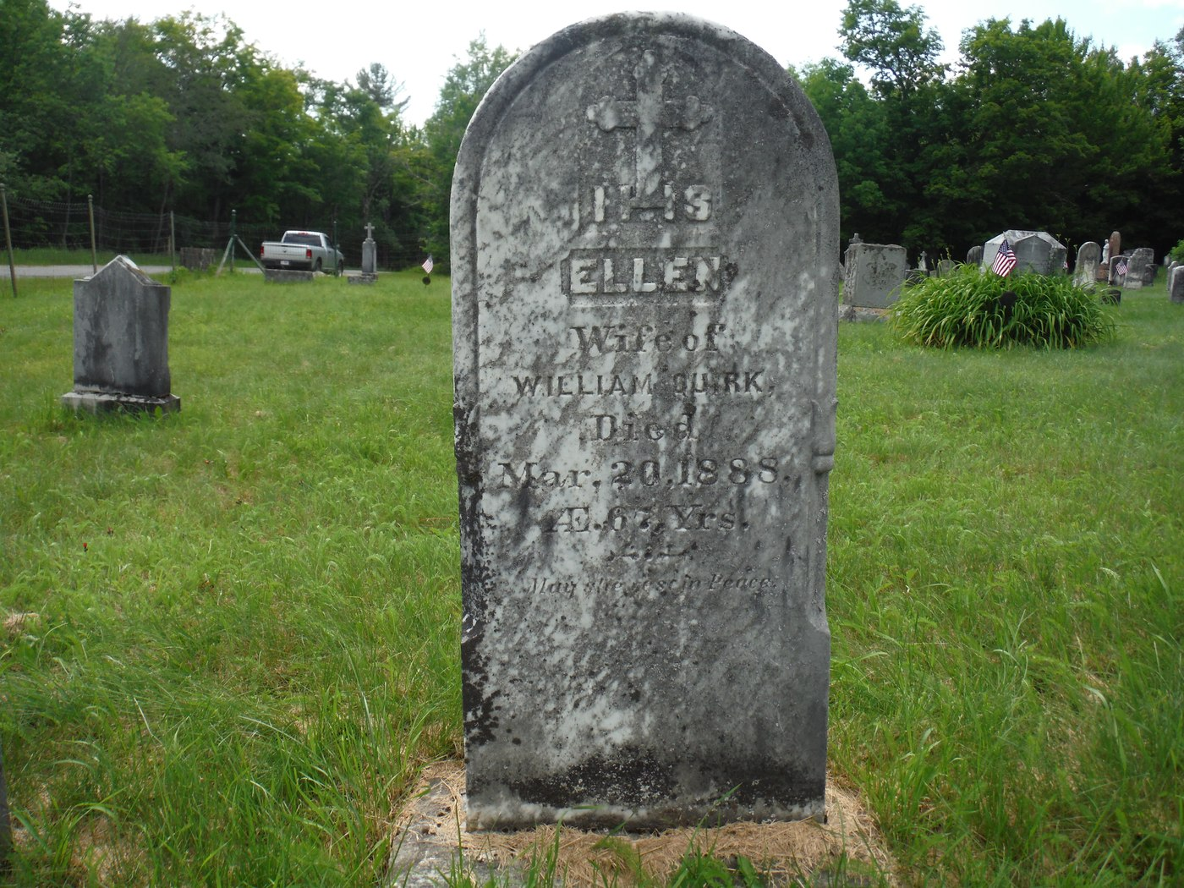
Ellen’s gravestone at St. Rose of Lima Cemetery, Alder Brook: “ELLEN, Wife of WILLIAM QUIRK, Died Mar. 20, 1888, Æ. 67 Yrs. May she rest in Peace.” It is also William’s only monument.
Walk outward from her stone and the whole cast of this document assembles around her. Her brother Timothy Howard, “native of Temple Derry, Tipperary Co., Ireland,” who shared her crossing on the Sweden and died seven weeks before she did. Her brothers Thomas and Dennis Howard. Her children: Edward and his wife Margaret Law and several of their children, including young Edward who died at eighteen; Margaret, the blind daughter who kept the farm; Julia; Anna Doyle, whose stone, like her mother’s, names her as a daughter of “W. & E. Quirk”; and Mary Quirk White on the White family monument beside her Civil War veteran husband. Around them lie the Ryans of Cappawhite, the Keeses of Gurreeney, the Gleasons, Collinses, O’Neils, Tearneys, Laws, and Doyles, the same names as the ship manifest, the census pages, the 1876 atlas, and the deeds, because this cemetery is the Tipperary neighborhood’s final gathering place. Two people are conspicuously absent from the stones: William himself and Sarah Howard Ryan, the family’s two earliest deaths, both almost certainly here in unmarked graves from the years before the community could afford marble.
The cemetery was fully transcribed by the Saranac Lake Genealogical and Historical Society, and that transcription, checked against every stone named in this document, is one of this project’s foundational sources. If the reunion allows time for one field trip, this is the one: the stones are a ten-minute drive from the old farm, and reading Ellen’s inscription in person, with this document in hand, is the closest thing the family has to standing in the presence of the first generation.

Part XI. What We Are Still Looking For
First, William’s exact death date, 1850–1855. Four archives may still hold it: the Frontier Palladium newspaper of Malone, digitized free at nyshistoricnewspapers.org, which may carry a death or estate notice; the Franklin County Surrogate’s Court letters of administration volume covering 1847–1864, browsable free on FamilySearch, since an administration petition would state his death date outright; the Gerrit Smith Papers at Syracuse University, whose land ledgers for Township 10, Lot 65 may record the original occupant and the circumstances of the 1855 sale to a widow; and the early Catholic registers of the Black Brook and Redford missions (Diocese of Ogdensburg), which served Alder Brook before it had a parish and could contain both the children’s baptisms and William’s burial.
Second, William’s arrival. The Boston customs lists of the 1830s and early 1840s deserve a systematic search, since his wife’s family used the Liverpool-to-Boston route; the New York State Archives’ alien depositions (1825–1913), filings that let non-citizens own land and sometimes state the date of entry into the United States, should be checked for both William, who occupied Smith land from 1844, and Ellen, who bought it in 1855; and Franklin County’s naturalization records should be searched for Quirk and Coughlin, because the 1888 probate testimony describes Ellen as a United States citizen, which in that era she could almost only have derived from a husband’s naturalization.
Third, the Irish generation. The Templederry Catholic parish registers, free on the National Library of Ireland site, are the place to seek William’s baptism about 1810, an Edward Quirke married to a Mary about 1800–1810, a predicted sister Julia, and the baptisms of Ellen, Timothy, and their siblings; Toomevara’s registers hold the Sarah Howard Ryan baptisms already found. Early register survival is patchy, and if the books do not reach back far enough, the Baurroe and Curragh valuation records will remain our best picture of the Irish Quirkes.
Fourth, the identity of Ellen’s second husband, Mr. Coughlin, via the New York State marriage index, 1881–1886, Franklin County. Fifth, smaller reconciliations: the Johanna/Anna death date (1892 versus the stone’s 1898), Julia’s birth date (1851 versus 1854), the precise placement of the executor Laurence Howard within the Howard family, and the exact kinship of Sarah Ryan, the half-aunt in the 1850 household. Sixth, the intra-family deeds hinted at by the records: Ellen’s conveyance of ten acres to Margaret before 1886 and the arrangement behind Edward’s ten-acre farm in 1880, findable in the Franklin County grantor index under Ellen Quirk, 1855–1886.

Sources and Records Consulted
Land records. Gerrit Smith and Ann Carroll Smith to Ellen Quirk, deed dated July 30, 1855, acknowledged July 31, 1855, Franklin County Deeds, Liber 24, page 431. John, Bridget, and Catherine Ryan to Edward Quirk, deed dated May 28, 1890, recorded May 31, 1890, Franklin County Deeds, Liber 87, page 305. Later conveyances of Lot 65 as cited in the family’s title timeline, Franklin County Clerk, Malone, N.Y.
Census records. 1850 U.S. Census, Town of Franklin, Franklin County, N.Y., dwelling 34, family 35 (William Quirk household), enumerated September 3, 1850. 1860, 1870, and 1880 U.S. Censuses, Town of Franklin (Ellen Quirk households). 1880 U.S. Census Non-Population Schedules, Agriculture, Town of Franklin (Ellin Quirk and neighbors).
Probate records. Will of Ellen Coughlin, dated November 6, 1886, admitted to probate December 31, 1888, Franklin County Surrogate’s Court: recorded in Wills Volume 9 (1887–1890), pages 275–279; Decrees Volume 1–2 (1879–1892); and Daybook Volume 1–2 (1880–1890), all accessed through New York, U.S., Wills and Probate Records, 1659–1999 (Ancestry).
Immigration. Massachusetts Arriving Passenger Lists and arrival index cards (NARA), Boston: Ellen Howard, accompanied by Timothy Howard, from Ireland aboard the Sweden, arrived June 4, 1845 (index card reproduced in Part II). Candidate arrivals for William Quirk at Saint John, N.B. (1833) and New York (June 10, 1837), unverified.
Cemetery. St. Rose of Lima Roman Catholic Cemetery, Town of Franklin, Franklin County, N.Y., full transcription by the Saranac Lake Genealogical and Historical Society (1977, updated 2001), published by the Northern New York Tombstone Transcription Project.
Irish records. Griffith’s Valuation, County Tipperary, Barony of Upper Ormond, Civil Parish of Latteragh, townlands of Baurroe, Curragh, Garrane, Glenmore Lower, Glenmore Upper, and Gurteen (published circa 1850–1853), with associated manuscript field books. Ireland, Catholic Parish Registers (National Library of Ireland), including Toomevara baptismal entries naming Sarah Howard. Family reconstruction of the Laurence Howard and Mary Margaret Kennedy family from Ancestry trees with DNA common-ancestor corroboration.
Newspapers and service records. Malone Palladium (1890), Malone Farmer (1933, 1935), Chateaugay Record (1913), and Tupper Lake Herald (1926), all via NYS Historic Newspapers. World War I draft registration and 1919 transport manifest for Lawrence Leo Quirk; U.S. Marine Corps muster rolls (1944–1945) for Leo L. Quirk; U.S. Army enlistment records for William Glenn Quirk.
Maps. County atlas of Franklin County, N.Y., 1876, plat of the town of Franklin (Alder Brook and Merrillsville neighborhoods), showing “Mrs Quirk” on Lot 65 among the named households of the community; reproduced in Part VII. Modern parcel and GIS overlays of Lot 65, Township 10, Old Military Tract, prepared by the family.
Local history. Historic Saranac Lake wiki articles on Alder Brook and St. Rose of Lima Church, including the history of the Irish settlement of 1848–1849 and the mission-era church. Research guidance from the FamilySearch wiki for Franklin County, the New York State Archives (alien depositions and naturalization leaflets), and NYS Historic Newspapers (Frontier Palladium and Malone Palladium).

With Thanks
This document stands on years of patient work. The bulk of the family research was done by Kelly Quirk, whose tree, records, and source-gathering on the family’s Ancestry.com page form the foundation of everything in these pages, and whose work inspired the rest. Building on that foundation, Aaron Quirk carried the research into the land itself: the deeds and title chain, the county record books, the historical maps, and the newspapers, which together turned a family tree into the story of a place. Thanks also belong to the record-keepers we will never meet: the census takers, surrogates, parish priests, atlas surveyors, and tombstone transcribers whose careful hands, across two centuries and two countries, saved this family’s story for us to find.
Compiled July 2026. Corrections, additions, and family memories are warmly invited; this is a living document.

